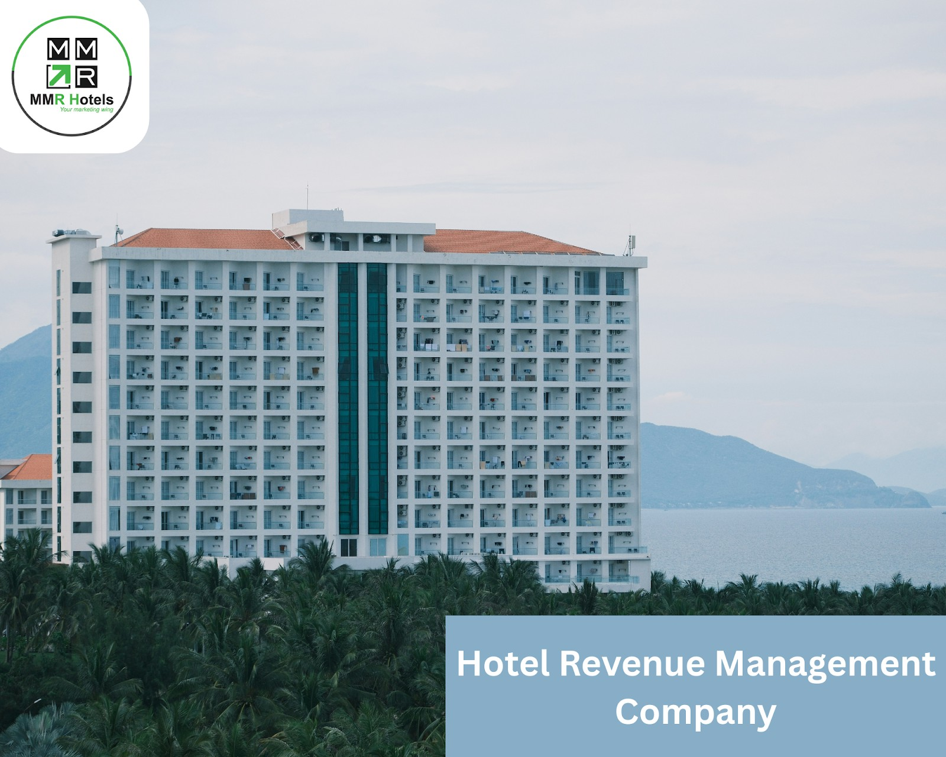Elevating Hotel Profitability: The Role of a Hotel Revenue Management Company

Maximizing revenue is crucial in the highly competitive hospitality sector. By using data-driven decision-making, inventory control, and smart pricing, a hotel revenue management organization helps hotels maximize their profits.

# Comprehending Hotel Revenue Management

The process of forecasting demand and setting the best room prices by examining market trends, past booking trends, and rival pricing is known as hotel revenue management. These insights are used by a seasoned [hotel revenue management company](https://mmrhotels.com/revenue-management-services/) to put plans into place that optimize revenue while preserving competition. This comprises smart market segmentation, efficient distribution management, and dynamic pricing, all of which help hotels attract the right customers at the right time for the right price.

One of a hotel revenue management company's primary services is dynamic pricing strategies.

The foundation of any effective revenue management strategy is dynamic pricing. Real-time room rate adjustments are made by a [hotel revenue management company](https://mmrhotels.com/revenue-management-services/) in response to factors including market trends, seasonality, local events, and variations in demand. Hotels can maintain their appeal during slower seasons and maximize earnings during high times by dynamically managing pricing.

# Management of Inventory and Distribution

Effective distribution of hotel inventory among various booking channels, including corporate clients, direct bookings, and internet travel agents, is guaranteed by a hotel revenue management company. Effective distribution management guarantees that income potential is fully realized, minimizes idle rooms, and avoids overbooking.

How to Pick the Best Company for Hotel Revenue Management

Success depends on choosing the best hotel revenue management company. Important things to think about are :

* + Experience and Performance History: Pick a business that has a track record of achievement in the hospitality sector.
  + Technological Proficiency: Make sure they make use of cutting-edge tools for analytics, forecasting, and pricing.
  + Tailored Solutions: Instead of providing generic programs, look for a provider that customizes methods to meet the specific demands of your hotel.
  + Transparent Reporting: The best business tracks ROI and performance with lucid, comprehensive reports.

# The Reasons MMR Hotels Are Unique

MMR Hotels is renowned among revenue management companies for offering all-inclusive solutions that optimize hotel profitability. As a committed hotel revenue management company, their staff of seasoned experts offers comprehensive services like market analysis, inventory optimization, dynamic pricing, and thorough performance reporting. MMR Hotels places a strong emphasis on tailored tactics that complement the objectives of each hotel, guaranteeing quantifiable outcomes and long-term expansion.

MMR Hotels uses technology, experience, and market insights to assist clients in achieving better occupancy, more income, and stronger market positioning, whether they are managing huge hotel chains, boutique hotels, or resorts.

Hotels can concentrate on delivering outstanding guest experiences while attaining steady financial growth by working with a reliable partner like MMR Hotels. Today's competitive hospitality sector makes having a skilled [hotel revenue management company](https://mmrhotels.com/revenue-management-services/) a strategic need rather than a luxury.