Medical Marijuana in Australia – Laws, Access, and Patient Benefits

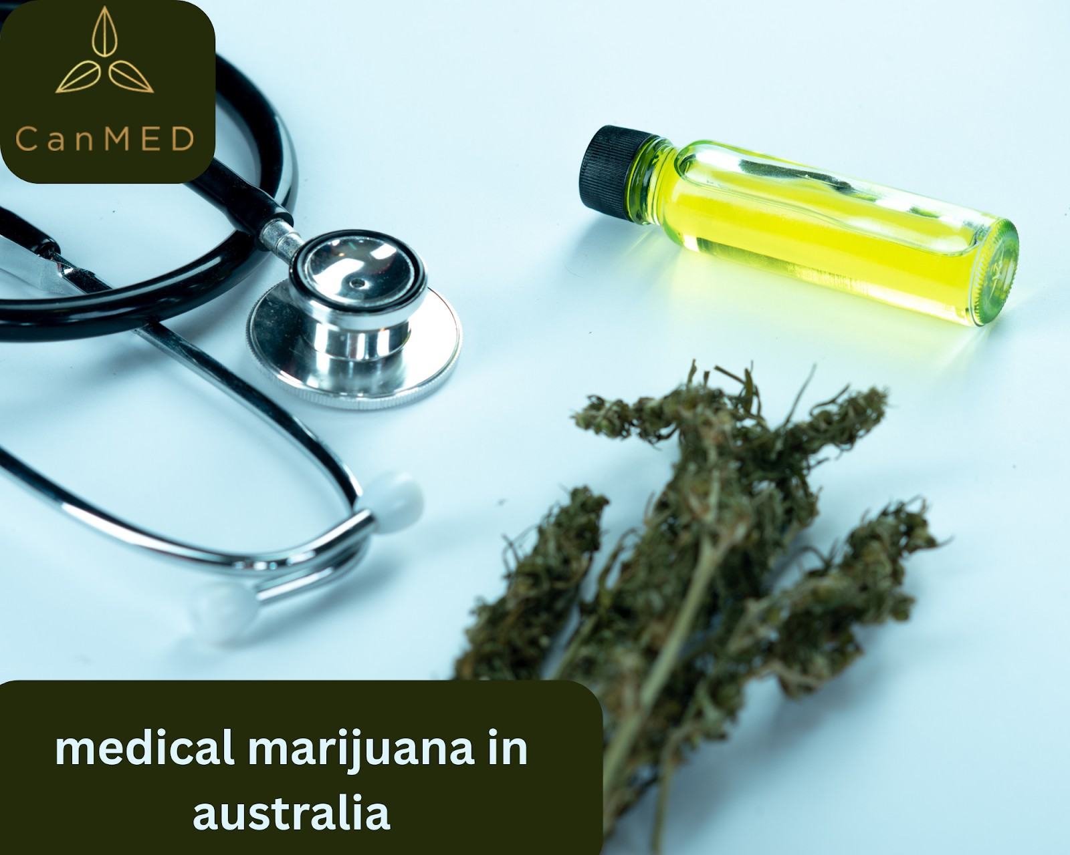

Over the past decade, cannabis has shifted from a taboo subject to a recognized part of modern healthcare. In Australia, this shift has been carefully regulated, with medical marijuana legalized in 2016 for patients with serious or chronic conditions. While recreational cannabis remains illegal, thousands of Australians now use cannabis-based medicines to manage symptoms where conventional treatments fall short.

This blog explores the legal framework, patient access, available products, benefits, challenges, and future of [medical marijuana in Australia](https://canmededucation.au/medical-marijuana-in-australia/).

# The Legal Landscape of Medical Marijuana

Medical marijuana was legalized in Australia in 2016, marking a turning point in national healthcare policy. Oversight is handled by the Therapeutic Goods Administration (TGA), which regulates cannabis products just as it does other medicines.

Access is restricted to medical purposes, ensuring cannabis is used responsibly. Patients can only obtain it with a prescription, and approvals often go through the Special Access Scheme (SAS) or the Authorized Prescriber pathway. This structured process aims to balance patient needs with public safety.

Unlike Canada or several U.S. states, recreational cannabis remains illegal in Australia. This distinction highlights the country’s cautious approach—prioritizing medical benefits while limiting potential misuse.

# How Patients Access Medical Marijuana

Getting [medical marijuana in Australia](https://canmededucation.au/medical-marijuana-in-australia/) involves more steps than filling a standard prescription. The process typically includes:

* Consulting a doctor willing to prescribe cannabis.
* Receiving approval through the TGA system.
* Filling the prescription at a licensed pharmacy or cannabis clinic.

Specialized cannabis clinics have become increasingly common, helping patients navigate approvals and offering access to doctors experienced in prescribing cannabis. While the system ensures safety, the process can still feel lengthy and complex, particularly for new patients.

# Medical Marijuana Products Available

One of the strengths of the system is the variety of cannabis-based medicines available to suit different medical needs. Patients can access:

* Oils and tinctures – popular for consistent dosing and ease of use.
* Capsules and tablets – prescribed when precision and convenience are priorities.
* Topical creams – used for inflammation, skin conditions, or localized pain.
* Dried flower – less common, but prescribed for patients who require fast symptom relief.

Every product is rigorously tested for quality and consistency, meeting strict pharmaceutical standards. This ensures patients receive safe, effective, and reliable treatment options.

# Conditions Treated with Medical Marijuana

The list of conditions treated with medical marijuana in Australia is expanding as research continues. Currently, cannabis is prescribed for:

* Chronic pain and neuropathy
* Multiple sclerosis symptoms
* Severe epilepsy (especially in children)
* Cancer-related nausea, vomiting, and appetite loss
* Insomnia and anxiety disorders

For many patients, cannabis offers a level of relief not achieved with conventional medications. Some use it to reduce reliance on opioids, while others find it improves daily functioning and overall quality of life.

# Benefits of Medical Marijuana

The growing use of medical marijuana reflects its proven and perceived benefits. Patients often report:

* Reduced pain and inflammation
* Improved sleep quality
* Relief from nausea and digestive issues
* Better mental health support for anxiety and PTSD
* Enhanced appetite for those undergoing cancer treatments

For doctors, cannabis represents an additional tool in the treatment toolkit. It is rarely the first option but can serve as a powerful complement when standard medicines prove ineffective or cause severe side effects.

# Challenges Facing the Industry and Patients

Despite its promise, the medical marijuana system in Australia is not without hurdles.

* Cost: Treatments are often expensive, with little or no insurance coverage.
* Access: Not all doctors are comfortable prescribing cannabis, limiting patient options.
* Stigma: Cannabis still carries social stigma, making some patients hesitant to explore it.
* Bureaucracy: The approval process, while improving, can be slow and complex.

These challenges create barriers for patients who might otherwise benefit from medical cannabis. Addressing them will be key to the industry’s growth.

# The Future of Medical Marijuana in Australia

Looking ahead, the future of medical marijuana in Australia appears promising. Patient demand continues to grow, and awareness among doctors is improving as research expands. Regulatory processes are gradually becoming more streamlined, making access easier.

There is also ongoing debate about recreational legalization, with some pointing to Canada and the U.S. as models. While that remains uncertain, the medical industry will continue to expand regardless, driven by research, patient outcomes, and evolving social attitudes.

As stigma fades, medical cannabis is likely to become a mainstream treatment option for a wider range of conditions.

# Conclusion

The legalization of [medical marijuana in Australia](https://canmededucation.au/medical-marijuana-in-australia/) has provided patients with new hope and new treatment options. Since 2016, the industry has grown steadily, offering regulated, safe, and effective

cannabis-based medicines for those in need.

While challenges like cost, stigma, and bureaucracy remain, the benefits are undeniable. Patients suffering from chronic pain, neurological disorders, and cancer-related symptoms now have an alternative pathway to relief. For many, medical cannabis means more than treatment—it means a better quality of life.

As research deepens and access improves, medical marijuana is set to play an even greater role in the future of Australian healthcare.

**Read More Blog :** [**https://discoverydell.com/cannabis-store-in-australia-legal-access-medical-use/**](https://discoverydell.com/cannabis-store-in-australia-legal-access-medical-use/)

[**https://discoverydell.com/alternate-medicine-consultancy-in-australia-your-path-to-holistic-wellne**](https://discoverydell.com/alternate-medicine-consultancy-in-australia-your-path-to-holistic-wellness-with-canmed/)[**ss-with-canmed/**](https://discoverydell.com/alternate-medicine-consultancy-in-australia-your-path-to-holistic-wellness-with-canmed/)