FVKD Exotics Disposable: The Game-Changer in Convenient Vaping

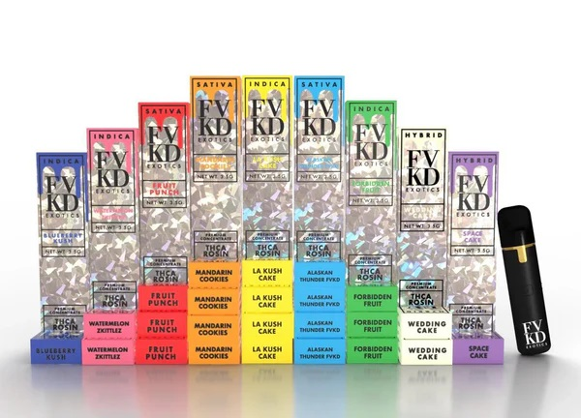

In today’s fast-paced world, the vaping industry continues to innovate, offering users a seamless, flavorful, and satisfying experience. Among the frontrunners in this competitive market is the **FVKD Exotics Disposable**, a product that has redefined what it means to enjoy vaping on the go. This revolutionary device combines cutting-edge technology with unparalleled convenience, making it a top choice for seasoned vapers and beginners alike.

**What Makes the FVKD Exotics Disposable Stand Out?**

The **FVKD Exotics Disposable** has captured [fvkd exotics](https://deltamonks.com/products/fvkd-exotics-thca-rosin-disposable-3-5g) the attention of vapers worldwide due to its impressive features. Here’s what makes it a standout in the crowded vaping market:

**Compact and Portable Design**

The FVKD Exotics Disposable is designed with convenience in mind. Its sleek and lightweight construction makes it easy to carry, whether you’re heading to work, traveling, or enjoying a night out. Unlike bulky vape devices, this disposable option fits comfortably in your pocket or bag, ensuring you always have access to a satisfying vape experience.

**Pre-Filled with Premium E-Liquid**

One of the key features of the FVKD Exotics Disposable is its pre-filled e-liquid chamber. This eliminates the need for messy refills or carrying around bottles of e-liquid. Each device comes filled with **high-quality, flavor-rich e-liquid**, ensuring consistency and satisfaction with every puff.

**Long-Lasting Battery Life**

Despite its compact size, the FVKD Exotics Disposable boasts an impressive battery life. The device is equipped with a high-capacity battery that outlasts many competitors in its class. This means you can enjoy uninterrupted vaping without worrying about frequent recharging or running out of power.

**Unmatched Flavor Profiles**

The FVKD Exotics Disposable is renowned for its diverse and **bold flavor options**, catering to a wide range of preferences. Whether you enjoy fruity, minty, or dessert-inspired flavors, there’s something for everyone. Some of the most popular flavors include:

* **Tropical Mango Bliss**: A sweet and tangy mango flavor that transports you to a tropical paradise.
* **Cool Mint Chill**: A refreshing burst of mint that leaves a cool sensation on your palate.
* **Berry Fusion Delight**: A medley of ripe berries with a hint of sweetness.
* **Creamy Vanilla Custard**: A rich and velvety dessert flavor perfect for indulgence.

Each flavor is meticulously crafted using premium ingredients, ensuring a smooth and enjoyable vaping experience every time.

**Ease of Use: A Perfect Choice for Beginners**

For those new to vaping, the FVKD Exotics Disposable is an excellent starting point. Its **draw-activated mechanism** means there are no buttons to press or settings to adjust. Simply inhale, and the device activates, delivering a smooth and flavorful vapor.

This simplicity, combined with its disposable nature, makes it a hassle-free option for first-time users. Once the e-liquid is depleted, the device can be safely discarded, eliminating the need for maintenance or cleaning.

**Environmentally Conscious Design**

While disposables often face criticism for their environmental impact, the FVKD Exotics Disposable takes steps to mitigate this. The brand uses **eco-friendly materials** and encourages responsible disposal practices. Additionally, the long-lasting battery and efficient e-liquid consumption reduce waste compared to lower-quality disposable devices.

**Safety and Quality Assurance**

Safety is a top priority for the makers of the FVKD Exotics Disposable. Each device undergoes rigorous testing to ensure compliance with industry standards. The **high-quality e-liquids** used are free from harmful additives, and the device itself is designed to prevent leaks and overheating.

**Why Choose FVKD Exotics Disposable Over Other Options?**

When comparing the FVKD Exotics Disposable to other disposable vapes, it becomes clear why this product is a top choice:

1. **Superior Flavor Consistency**: Each puff delivers the same rich flavor, ensuring an enjoyable experience from start to finish.
2. **High Puff Count**: The FVKD Exotics Disposable offers a higher puff count than many competitors, giving you more value for your money.
3. **No Maintenance Required**: Unlike traditional vape devices that require coil replacements and regular cleaning, this device is ready to use straight out of the box.
4. **Affordable Price Point**: Despite its premium features, the FVKD Exotics Disposable is priced competitively, making it accessible to a wide range of users.

**How to Get the Most Out of Your FVKD Exotics Disposable**

To maximize your vaping experience with the FVKD Exotics Disposable, follow these tips:

* **Store Properly**: Keep the device in a cool, dry place to preserve battery life and e-liquid quality.
* **Pace Yourself**: Take slow, steady puffs to enjoy the full flavor and prevent the device from overheating.
* **Dispose Responsibly**: When the device is empty, dispose of it according to local regulations to minimize environmental impact.

**Customer Reviews and Feedback**

The FVKD Exotics Disposable has garnered rave reviews from users worldwide. Many praise its **rich flavors**, long-lasting performance, and ease of use. Here are a few testimonials:

* “I’ve tried countless disposable vapes, but nothing comes close to the FVKD Exotics Disposable. The flavors are incredible, and the battery lasts way longer than I expected!”
* “As a beginner, I found this device super easy to use. No buttons, no mess—just pure vaping pleasure.”
* “The FVKD Exotics Disposable is my go-to vape when I’m on the move. It’s compact, reliable, and always delivers a satisfying hit.”

**Where to Buy the FVKD Exotics Disposable**

The FVKD Exotics Disposable is available at most major vape retailers and online stores. Look for **authorized sellers** to ensure you’re purchasing an authentic product. With competitive pricing and regular discounts, it’s easier than ever to experience the convenience and quality of this game-changing device.

**Final Thoughts**

The **FVKD Exotics Disposable** is a shining example of innovation in the vaping industry. Its blend of portability, premium flavors, and user-friendly design makes it a top contender for anyone seeking a reliable and enjoyable vaping experience. Whether you’re new to vaping or a seasoned enthusiast, this device is sure to exceed your expectations.

Invest in the FVKD Exotics Disposable today and discover why it’s hailed as a game-changer in convenient vaping.