Going Beyond Jeans: Why Kilts Are the Modern Man’s New Favorite

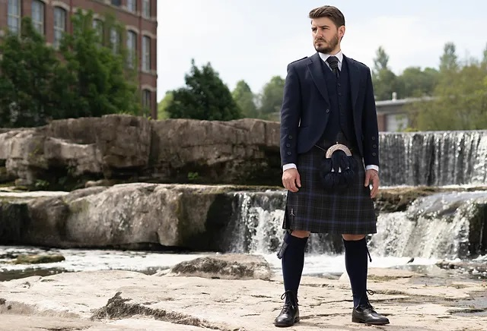

Kilts for men are back incredibly, and they're something other than a sign of approval for Scottish custom. Once saved for functions or Good country social affairs, kilts are presently tracking down their position in the style standard. From present day style turns to immortal examples, kilts are assuming control over the scene, mixing social history with contemporary style. In this article, we plunge profound into why kilts are getting back in the game and how men can with certainty wear them to say something in any setting.

The Ascent of Kilts in Present day Men's Design

Kilts have a rich history that stretches back [kilts near me](https://scottishattire.com/kilts-for-men) hundreds of years, established in the high countries of Scotland. Initially worn as an image of Scottish legacy, kilts turned into a seal of versatility and social pride. Today, the kilt has extended past its customary importance, interesting to men overall who need to blend legacy in with uniqueness. However, why the flood in notoriety now?

Kilts and the Shift Toward Independence

The design world has been embracing the shift toward extraordinary and customized articulations of style. Kilts offer men a method for separating themselves from the group, offering a strong expression that goes past regular pants or pants. A kilt, with its particular plan and well established social affiliation, permits men to show they are certain and unafraid to stick out. The reestablished interest in kilts flags a time where dress is a type of individual account, and everything better method for telling a story than with a piece of clothing that epitomizes hundreds of years of history?

Superstar Impact and Kilts in Mainstream society

High-profile superstars like Ewan McGregor, Gerard Steward, and even figures like Vin Diesel have been spotted wearing kilts, carrying them into the standard. At the point when these notorious men wear kilts on honorary pathway or in broad daylight, they challenge style standards and urge others to do likewise. These public presentations of kilt design show that it's adequate as well as sharp to split away from show. This impact has contributed fundamentally to the kilt's resurgence, demonstrating that they're relics of the past as well as important in the present current world.

The Cutting edge Kilt: Something other than a Scottish Practice

While the conventional plaid kilt actually holds pride of spot, present day variations are giving the piece of clothing a new allure. Originators have developed on the exemplary plan, utilizing various materials, tones, and examples, making kilts more flexible than any other time in recent memory.

Contemporary Kilt Styles

Utility Kilts: These kilts are frequently created from tough materials like material or denim, intended for capability and solace. Utility kilts have pockets and are reasonable for relaxed or even workplaces. The rough look of a utility kilt makes it ideal for the individuals who need to add a touch of edge to their regular clothing.

Crossover Kilts: Mixing components from conventional plaid kilts with current textures and cuts, mixture kilts offer a contemporary twist. These kilts are famous with men who need to respect custom however favor a lighter, more breathable texture for ordinary wear.

Cowhide Kilts: For those hoping to offer a bolder expression, calfskin kilts carry a dash of defiant style to the exemplary kilt. Frequently connected with punk culture, calfskin kilts are a phenomenal decision for men who need to ooze certainty and a solid fashion instinct.

Design Kilts: A class where originators try different things with examples, varieties, and styles, design kilts can go from moderate and smooth to energetic and eye catching. They take care of the great design swarm and are ideal for the individuals who need a kilt that is a genuine articulation of individual style.

The Social Meaning of Plaid and Plaid

The exemplary plaid design related with kilts is wealthy in imagery. Every plaid is extraordinary to a particular faction or family, permitting wearers to address their legacy or individual character. Plaid has now extended past its Scottish roots, as creators integrate plaid into kilts that enticement for a more extensive crowd. By wearing a plaid kilt, men are interfacing with an account of custom, flexibility, and family pride that rises above borders.

The most effective method to Style a Kilt in the Cutting edge World

Kilts might appear to be scaring to style, particularly for those new to this article of clothing. In any case, matching kilts with ordinary clothing can be both straightforward and sleek. This is the way to make a kilt work for different settings, from formal occasions to easygoing trips.

Styling a Kilt for Formal Occasions

For formal occasions, embrace custom by matching an exemplary plaid kilt with a Sovereign Charlie coat or an Argyll coat. These coats are intended to supplement the kilt and are generally worn with a dress shirt, petticoat, and necktie. A sporran (the conventional pocket worn with kilts) can add validness and is in many cases decided to match the custom of the occasion.

On the off chance that the occasion is less formal, consider wearing a tweed coat with a more muffled plaid kilt. This mix has a complex look that functions admirably for weddings, gatherings, or upscale get-togethers. Remember to complete the look with a kilt pin and ghillie brogues (customary Scottish shoes with bands that fold over the lower leg) for a cleaned appearance.

Wearing Kilts Nonchalantly

For a more loosened up style, utility kilts or mixture kilts are great. Match these kilts with a straightforward Shirt, a fitted coat, or an easygoing conservative shirt. You can wear shoes, boots, or even shoes with easygoing kilts, contingent upon the event and the energy you're going for.

In the event that you're donning a utility kilt, add a cowhide belt to upgrade the rough look. Decorate with an easygoing sporran or skip it by and large on the off chance that the kilt has pockets. Relaxed kilts look incredible with hoodies, denim coats, and vests, offering a cool, easygoing style that is both utilitarian and outwardly engaging.

Decorating Your Kilt

Extras can represent the deciding moment a kilt outfit. Here are a few basics to consider:

Sporran: Pick a sporran that matches the tone of your outfit. Cowhide or fur sporrans function admirably for formal looks, while material or straightforward calfskin is appropriate for easygoing styles.

Kilt Pin: This little detail adds character to your kilt. Choose a pin that supplements your outfit; for instance, a family peak pin for a customary touch or a cutting edge, downplayed plan for easygoing wear.

Belt and Clasp: A strong belt with a novel clasp can add definition to your waistline and upgrade your kilt's appearance. For utility kilts, a wide, solid belt adds to the rough look.

Hose and Blazes: Kilts are commonly worn with knee-high socks (kilt hose) and glimmers, little shaded groups that safe the socks. These add a pop of variety and can be composed with your kilt or sporran.

Why More Men Ought to Think about Wearing Kilts

The allure of kilts goes past style; they address opportunity, solace, and a break from ordinary menswear. Numerous men report that kilts offer better solace thought about than pants, particularly in hotter environments. The free-streaming plan permits better air flow, pursuing kilts an incredible decision for outside occasions or dynamic settings.

Kilts likewise offer a mental shift. Wearing a kilt can be engaging, testing cultural standards and empowering fearlessness. Men who decide to wear kilts frequently discover themselves feeling a more grounded association with their own personality and legacy, as well as a deep satisfaction in sticking out.

Breaking Orientation Standards

As of late, design has been advancing toward impartial styles, and kilts add to this shift. By wearing a kilt, men break liberated from severe orientation assumptions, embracing the piece of clothing as an all inclusive garment. The kilt is a magnificent illustration of a piece of clothing that opposes orientation standards and celebrates self-articulation without limitation.

Where to Track down Great Kilts

With the resurgence in kilt prominence, various retailers and custom tailored shops offer top notch kilts for each spending plan. Here are a few contemplations while picking where to purchase:

Specialty Kilt Shops: These stores frequently offer a scope of customary and present day kilts, considering customization in plaid choice, fit, and frill.

Online Retailers: For additional reasonable choices, online retailers give various kilts in various styles. Search for legitimate brands that utilization quality materials.

Custom Designers: For a special kilt that mirrors your precise taste, think about a custom designer. Customized kilts give the best fit and take into account total personalization.

Last Contemplations on the Kilt Restoration

Kilts are back and setting down deep roots, mixing custom with present day energy. They're an immortal piece of clothing that has developed to satisfy the present design guidelines, offering men a flexible and enabling closet decision. Whether you're going to a conventional occasion, investigating relaxed style, or making a striking design explanation, there's a kilt for each event.

In this way, embrace the kilt rebound with certainty. Not exclusively will you be praising a piece of clothing with profound verifiable roots, however you'll likewise be making an exceptional style proclamation that is particularly your own.